DAT 510 uCertify Lab Activity Worksheet

Module Labs
Module One
1.7.1 Reading Data From a CSV File
1.7.9 Loading Data Into a Dataframe

Lab Screenshots

1.7.1 Reading Data From a CSV File
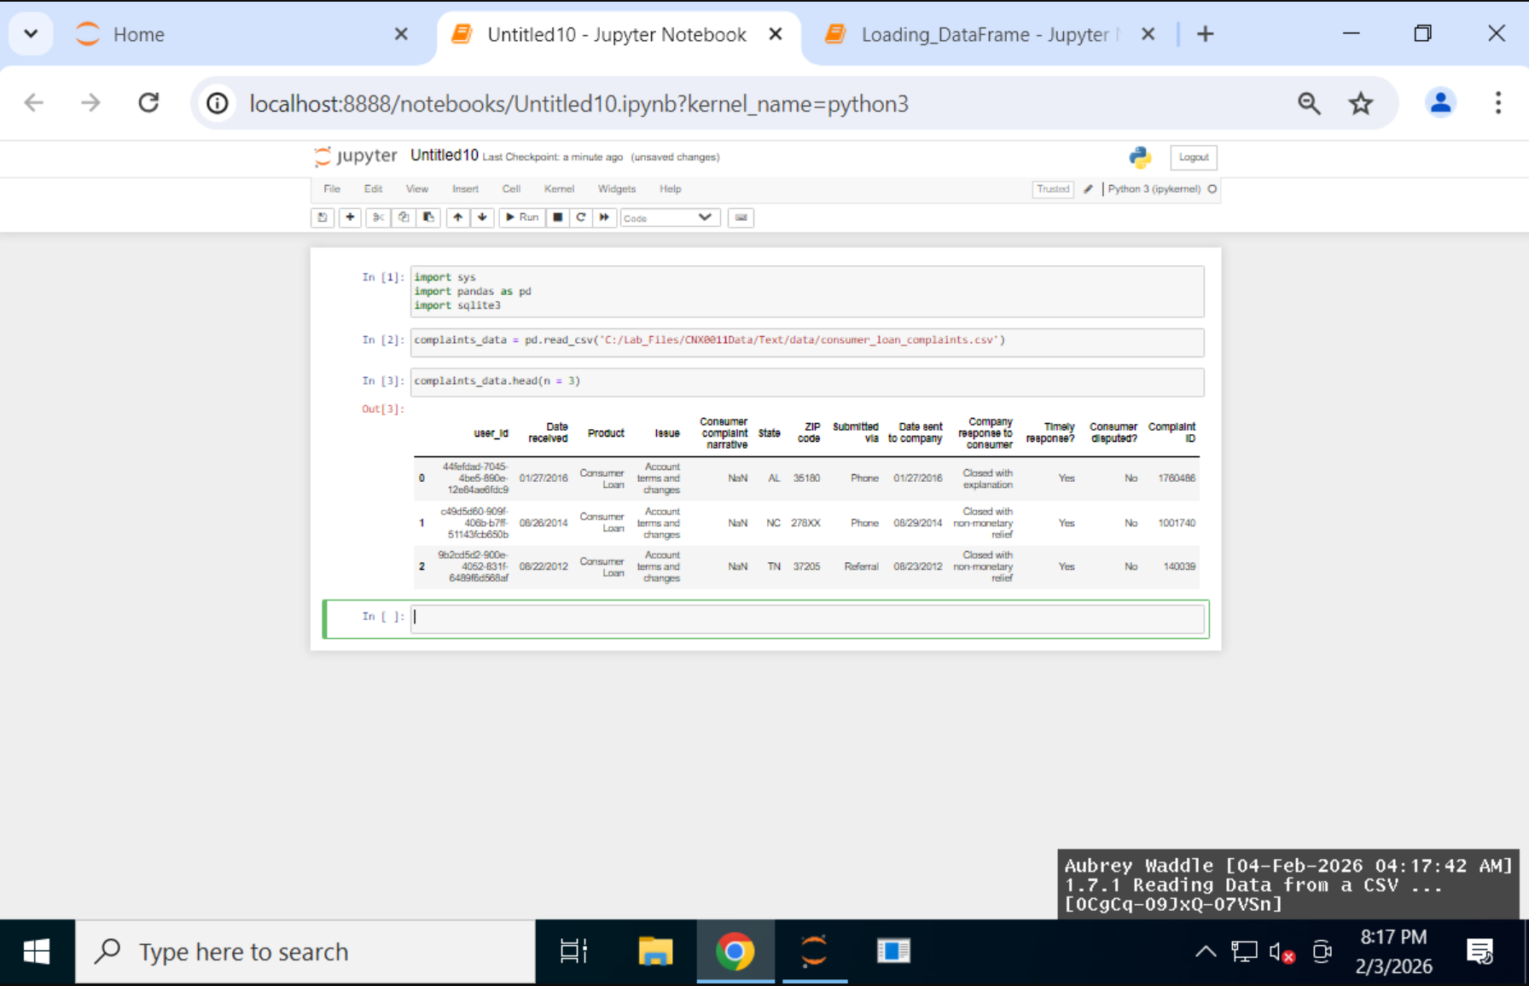

1.7.9 Loading Data Into a Dataframe
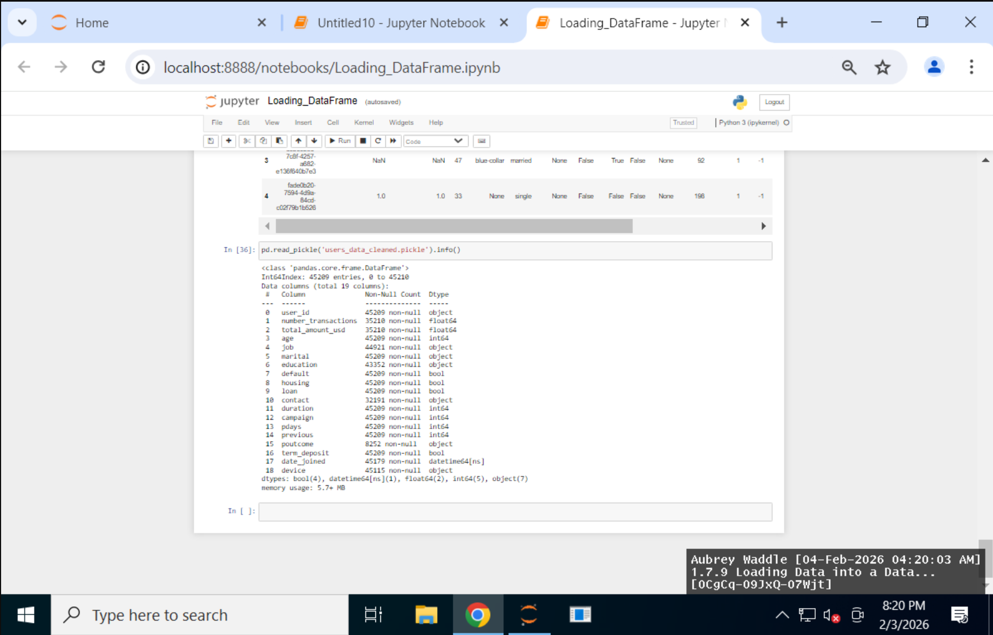

Lab Reflection

This week’s uCertify labs were mainly about getting more comfortable with Python and pandas for loading and looking through data. I worked with both pickle files and CSV files, using functions like read_pickle(), read_csv(), head(), and info() to bring the data into DataFrames and quickly see what was inside. Most of the work was just previewing rows, checking column types, and noticing where values were missing or inconsistent before doing anything more advanced. Even without full charts or graphs, the tables and summaries still worked like quick visual checks that helped me understand the data better.

These skills are useful in almost any job that deals with data, especially data analyst or reporting roles. They’re most helpful at the beginning of a project when you need to clean or organize data before building dashboards or models. Even though the steps are a bit technical, the information you get from them can easily be turned into simple visuals or summaries later for managers or other non-technical audiences.

